2023 reading report
In 2023, I read 74 books, with an average rating of 4.54 of 5 stars.
Figure 1 shows what that looked like over time:
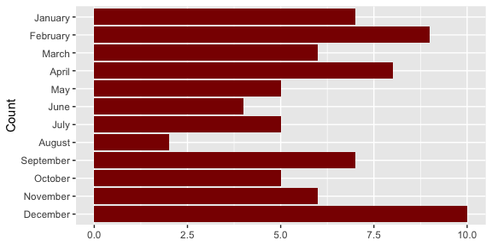
Figure 1: Books read in each month of 2023

